Power Automate
- What is connection and connection reference
Ans -
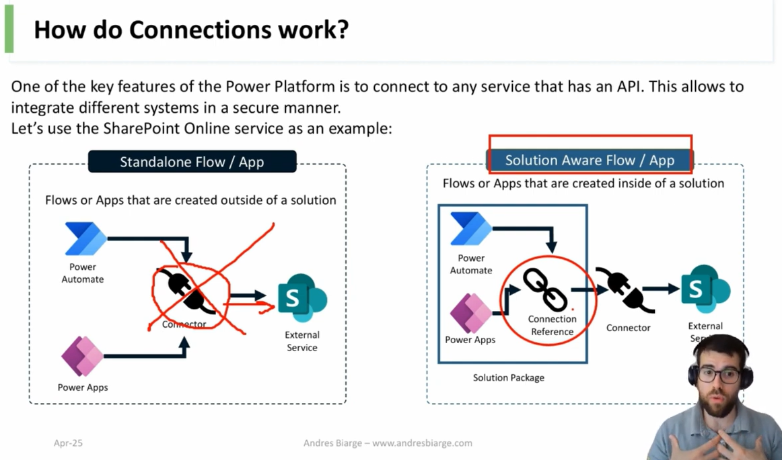

Connection

- A connection is used to connect Power Automate/Power Apps to services (e.g., Outlook, Dataverse, SharePoint).
- Contains all authentication details required to access the service.
- Connections are not solution-aware, so they cannot participate in ALM.
- Connections cannot be shared directly with other users.
- Flow owners can see and use shared connections.

Connection References
- Connection references are solution-aware and can move through environments in ALM.
- Connection references must be added from within a solution.

2. Types of Users in Microsoft Dynamics 365 CRM
1. Licensed Users (Full Users)
- Users with a full Dynamics 365 license.
- Can access all CRM apps (Sales, Service, Field Service, custom apps).
- Have full read/write permissions based on assigned security roles.

2. Team Member Users (Light Users)
- Limited access license.
- Can read most records but can create/update only basic entities (e.g., Activities, Contacts).
- Cannot fully use modules like Opportunities, Cases, Work Orders.

3. Admin Users
- Includes Global Admin, Dynamics 365 Admin, Power Platform Admin.
- Used for system configuration, user management, environment management.
- Access given through security roles like System Administrator.

4. Application Users
- Used for integrations and API access (service accounts).
- Represent Azure AD app registrations.
- Do not need a Dynamics license but must be assigned proper security roles.
- Used for server-to-server authentication.
- Where is the Application User?
Ex –
When CRM and BC integrate using:
Virtual tables
Custom APIs
Power Automate + Azure AD OAuth2

The backend calls CRM using:
👉 Client ID (App Registration) → CRM Application User
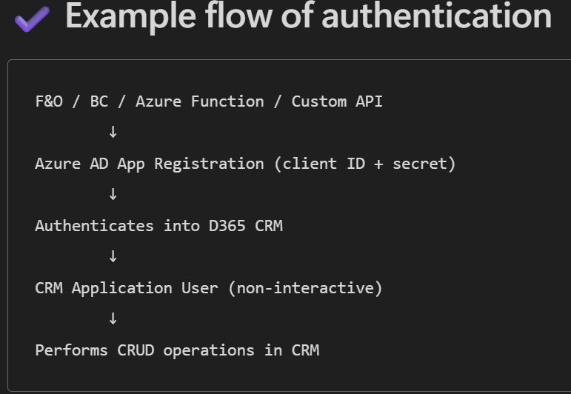

5. Non-Interactive Users
- Used for background operations only.
- Cannot log in manually.
- Older concept; mostly replaced by Application Users.

6. Power Pages / Portal Users
- External users accessing Power Pages sites.
- Authenticated via email, AAD, or other identity providers.
- Mapped to Contact records in CRM.

7. Guest Users (External AAD Users)
- External users invited to your Azure AD tenant.
- Require a Dynamics license assigned from your tenant.
- Access CRM based on assigned security roles.

Note - Licensed users are people with UI access and need a Dynamics license, while application users are service accounts(non-human) used for API/integration access and do not need a Dynamics license (but must have security roles).
- Environment Variable
Environment Variables are configuration values stored inside a Solution so that your flows, plugins, apps, and integrations work without hardcoding anything.
Use case 1 - They help your solution work in:
- Dev
- Test
- UAT
- Prod
without changing any flow or plugin manually.
- Use case 2- Environment variables remove hardcoding of:
URLs
App IDs
Secrets
API endpoints
Record IDs
Connection strings
External system configuration

They make your solution ALM safe.
WHAT HAPPENS WHEN YOU IMPORT TO PRODUCTION?
When you import the solution → Production will detect:
“These environment variables have no Current Value in this environment. Please provide value.”
You will see a prompt like:
Provide Current Value for Environment Variables
Then you (or the admin) must enter the correct Production values:

Example (PROD):
Variable | Current Value
crm_url | https://prod.crm.dynamics.com
app_id | 789-prod-app-id
api_base_url | https://prod.api.com

E.g. –
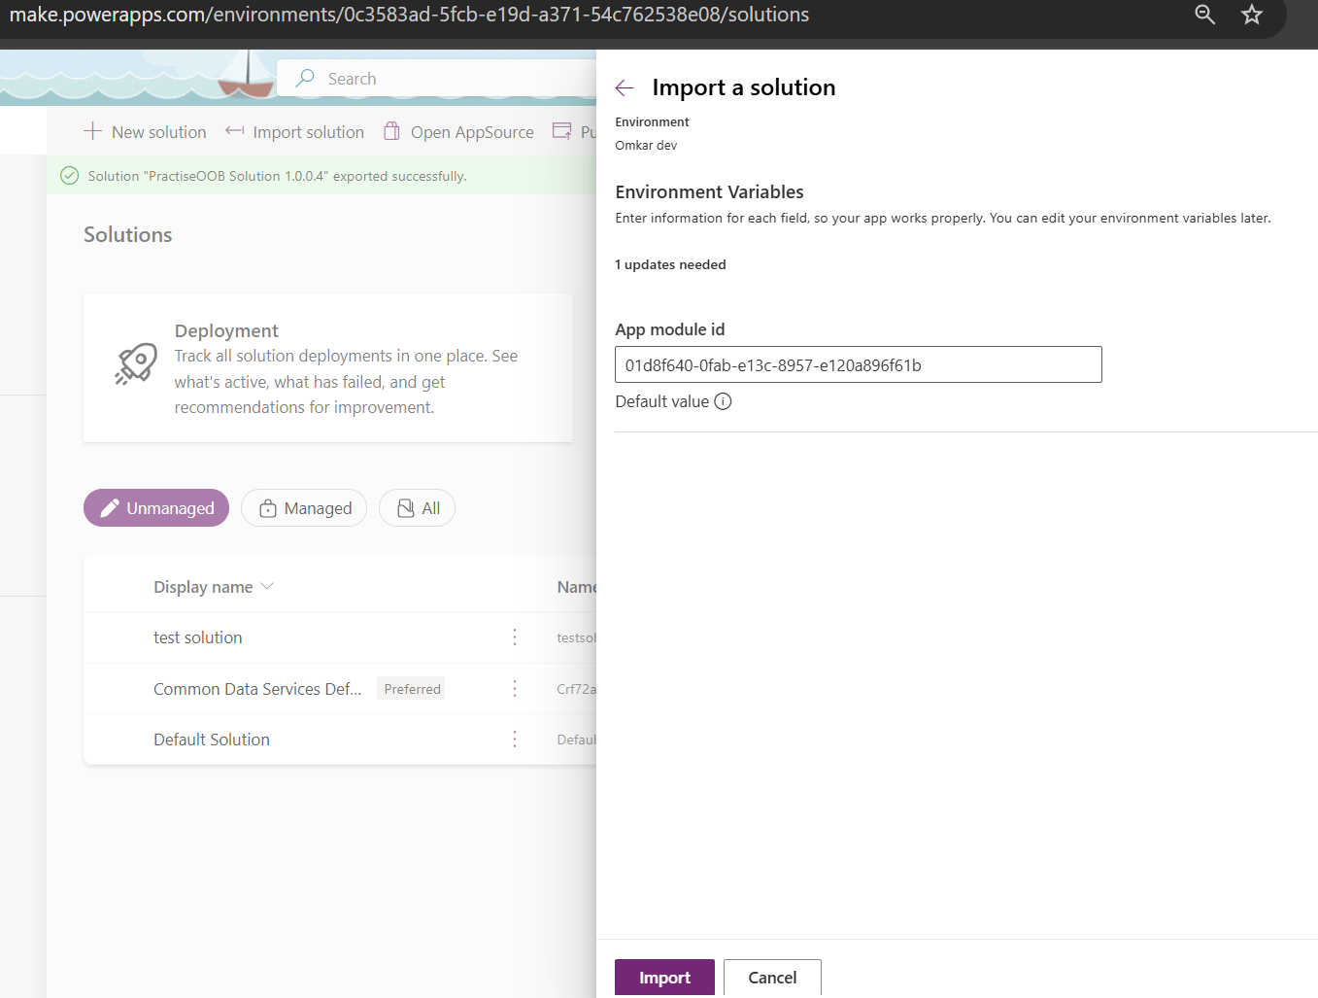

Environment Variable using the Plugin
context.GetEnvironmentVariableValue("crm_url");

Q. What is pagination?
Default page size is 5,000 rows per request. With Pagination ON, you can set Threshold up to 100,000; Power Automate will internally keep following pages (server still returns 5,000 at a time). Above 100,000, you must page manually (turn Pagination OFF and loop using @odata. nextLink / Skip token).

How to Enable Pagination (Step-by-step)
1. Open your action
Example: List rows, List records, Get items, HTTP, etc.
2. Click the “•••” (ellipsis) → Settings
3. Turn ON “Pagination”
4. Set the “Threshold”
This is the maximum number of items the action should retrieve.
Example values:
5000 (common for Dataverse)
10000
100000 (maximum in many connectors)

Example: Dataverse – List Rows
Dataverse returns 5,000 max without pagination. It is a limitation of list rows
Enable pagination → Set threshold (e.g., 50,000).
Power Automate will automatically retrieve:

Page 1
Page 2
Page 3
Until threshold is reached
Also note - To call a child flow from parent flow they should be present in same solution
Power Automate behavior (Dataverse – List rows)
Default page size is 5,000 rows per request. With Pagination ON, you can set Threshold up to 100,000; Power Automate will internally keep following pages (server still returns 5,000 at a time). Above 100,000, you must page manually (turn Pagination OFF and loop using @odata. nextLink / Skip token).

Also note:
When Pagination is ON, Power Automate suppresses @odata.nextLink in the output. To manually page, turn Pagination OFF so that @odata.nextLink is present. [learn.microsoft.com]
For FetchXML in List rows, the Pagination toggle doesn’t apply; use FetchXML page attribute + paging cookie approach

Q. What is Odata.nextlink and Skiptoken?
1. Skip token –
Skip Token is an encoded pointer used by Dataverse OData API for server-side paging.
When a dataset is too large, the API returns @odata.nextLink, which contains a skiptoken.
This token tells the server where to continue retrieving the next set of records.
Skip tokens ensure efficient paging without loading all records at once.

$skiptoken is an opaque paging token embedded inside @odata.nextLink. It tells the server where to resume. You don’t construct it yourself—you just pass back what the server gave you, either:
If Pagination is ON
You can set threshold up to 100,000 records.
Power Automate does:
- Call first page
- Read @odata.nextLink
- Use skiptoken to call next page
- Repeat until no nextLink exists

by calling @odata.nextLink directly (OData), or
by passing the paging cookie & page number for FetchXML paging
2.Odata.nextlink
When you query Dataverse via the Web API (OData), results come back in pages (up to ~5,000 rows per page). If there are more rows to fetch, the response includes a property called @odata.nextLink.
This is a URL you can call next to get the next page of result
A) When Pagination is OFF (manual paging)
- The List rows output includes @odata.nextLink if more data exists.
- You can then parse the skiptoken from that URL and call the next page in a loop. [learn.microsoft.com]
Flow outline (unlimited rows):
- List rows (Pagination OFF).
- If body/@odata.nextLink exists → extract the $skiptoken into a variable.
- Do until the skiptoken is empty:
  - List rows again but set Skip token = the extracted token.
  - Append rows; update the token from the new @odata.nextLink.
(Stop when @odata.nextLink is empty.)
When Pagination is ON (auto-paging)
- You can set the Threshold up to 100,000 rows. Power Automate will auto-page internally and won’t expose @odata. nextLink in the output.
- If you need >100,000 rows, turn Pagination OFF and implement the manual loop above.
Note: Default page size is 5,000; threshold is rounded in chunks of 5,000 and capped at 100,000.

Plugins
1.Use of secondary entity
In Plugins and Plugin Registration Tool (PRT), the Secondary Entity is used only for messages that involve TWO entities, such as:
- Associate
- Disassociate
- Assign
- Merge
- QualifyLead
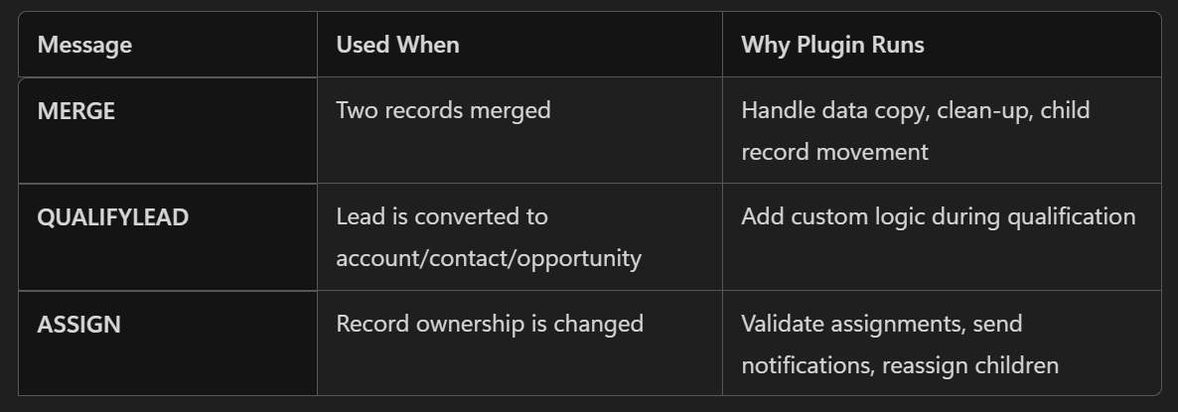

E.g –
1.Relationship operations — Associate / Disassociate
These messages link/unlink records across N:N or 1:N relationships.
Primary Entity = one side of the relationship; Secondary Entity = the other side.

Q. Message Name - Associate and deassociate =>

Target = EntityReference (not Entity)
It is the primary entity of the association.

You are associating a Contact to an Account:
• Target = Account (EntityReference)
• RelatedEntities = Contact(s) (EntityReferenceCollection)
• Relationship = name of relationship (e.g., "contact_customer_accounts")
CODE-
try
{
tracingService.Trace("start plugin execution: {0}", this.GetType().FullName);
if (context.InputParameters.Contains("Target") && context.InputParameters["Target"] is EntityReference && context.ParentContext == null)
{
tracingService.Trace("Parent Context is null");
if (context.MessageName == "Associate")
{
if(context.InputParameters.Contains("Relationship") &&
((Relationship)context.InputParameters["Relationship"]).SchemaName.Equals("schemaname"))
{
tracingService.Trace("Relationship Found");
if (context.InputParameters.Contains("RelatedEntities") && context.InputParameters["RelatedEntities"] is EntityReferenceCollection)
{
var primaryEntity= (EntityReference)context.InputParameters["Target"];
var relatedEntities= context.InputParameters["RelatedEntities"] as EntityReferenceCollection;

Many To Many relationship
2. Ownership transfer — Assign
- Assigning an account to a user/team:
  - Primary Entity = account
  - Secondary Entity = assignee type (systemuser or team)
3. Queueing — AddToQueue / RemoveFromQueue
- Moving a record into a queue involves two entities.
  - Primary Entity = the record (e.g., incident)
  - Secondary Entity = queue

2.How to call a Api using the plugin?
Ans –
  - Use the Http client
  - Create a new instance
  - Setup the timeout – Wait for Api to respond for this particular time
  - Use string url =”Api URL ”
  - Get a response using the http client instance and use the getAsync(url). result method
  - Store the response in a string variable using the response.content. ReadAsStringAsync().result;
  - Update the data
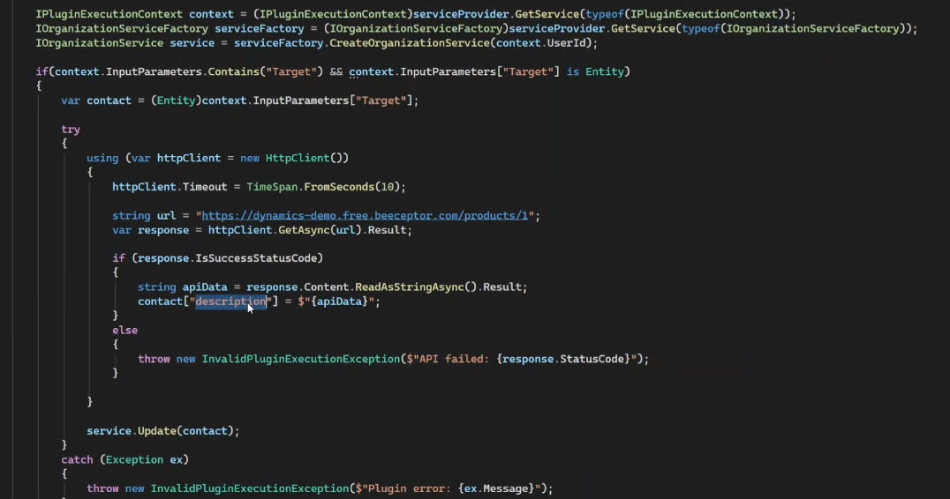
Register it on plugin registration tool on message and perform operation
Q. How to use API key in plugin other than secured and unsecured config
Ans – 1. Environment variable

Functional Interview Questions
1. How to change the number of rows in subgrid?
Ans –
